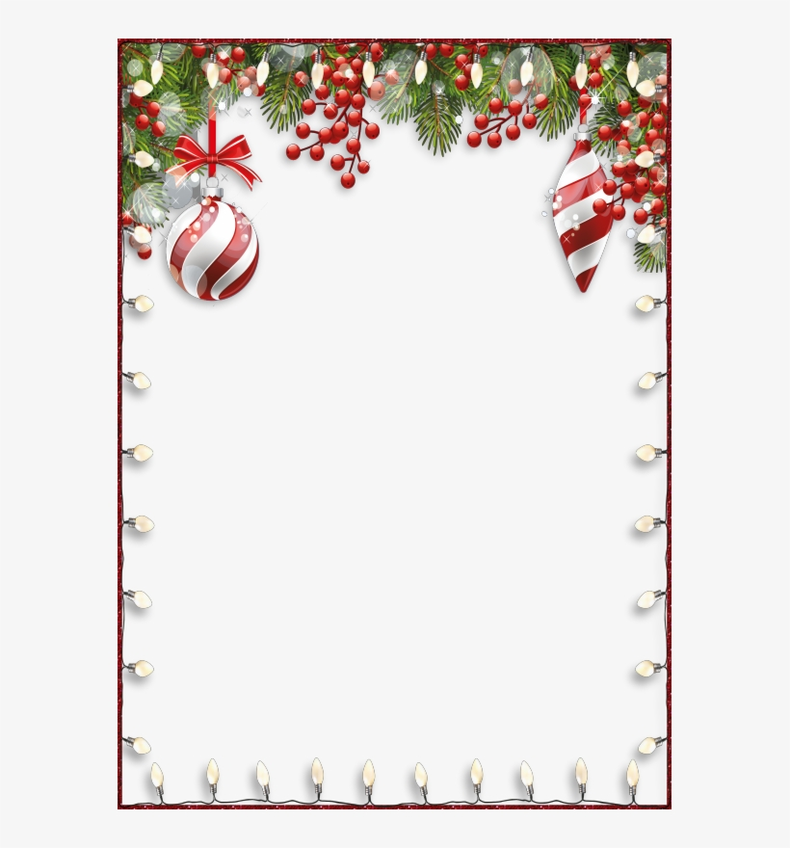

Omaha AA
Christmas Party
Saturday, December 4, 2021
Scottish Rite Masonic Center
202 S 20th St. Omaha, NE
Speaker – Judith R from Bismark, ND
5 pm - Doors open and Social Hour
6 pm – Dinner
7 pm – Entertainment & Raffle
8 pm – Speaker with Dance to follow
**Dinner Tickets are pre-sale only
through November 26th**
Tickets - $25 speaker with dinner and dance
$15 speaker and dance only
To reserve a craft table, please call Terry M 402-305-2091
To donate raffle items, please call Gary K 402-301-1166

Please support our Central Office with its ONLY fundraiser!

