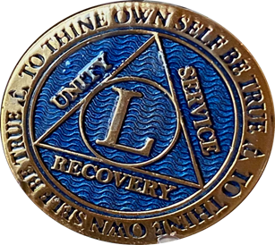

What: Celebration of 50 years of Sobriety!!!!!!!
Who: Frank C.
When: Saturday June 3rd 2023
11:15 am – 1:00 PM
Where: 12 Step House Lower Level
7306 Grant Street

Please feel free to attend the AA meeting at 10:00 AM.______________________________
If you would like to bring an appropriate refreshment, desert, or casserole please do.

For questions: Barry B. @ 402-594-5961

